ECMAScript is generally used for client-side scripting, and it is also used for writing server applications and services by using [Node.js](https://www.javatpoint.com/nodejs-tutorial). ES6 allows you to write the code in such a way that makes your code more modern and readable. By using ES6 features, we write less and do more, so the term 'Write less, do more' suits ES6.

**Literals**

Literals are the numbers,characters,strings etc . **Generally, literals are used for initializing the variables**

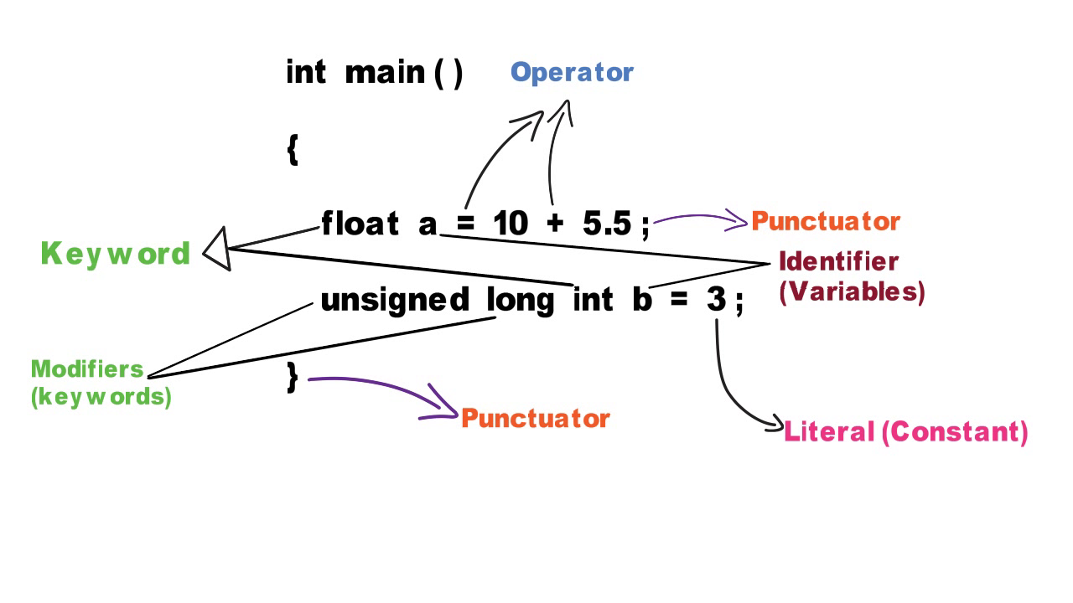

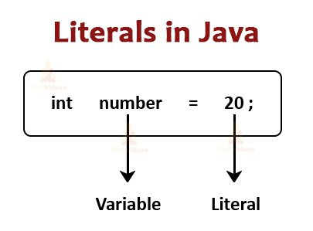

**The Strict Mode**

Sometimes while coding humary code ma buht sa minor errors hoty hain jo ka humain by default show nhi hoty ya wo warnings ma show hoty hain lekin kionky wo errors ma show nhi hoty tu hamain unka malom nahi hota aur bad ma ja kar wo minor errors kafi issues problems create krty hain.Msln

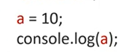

Msln is code ma koi bhi error hamain dekhny pr bazahir nahi show ho raha kionky sb kuch thek ha lekin ismy ek minor error ha aur wo ye ka humny variable a ki data type nahi batai aur bad ma jak kr issue/problem create kr skta ha ye error.is liay agr hum chahty hain ka wo minor errors jo bazahir hamain show nahi ho rahy wo hum dekh sakain tu hamain ‘use strict’ mode use krna ho ga

